Heuristic Evaluation for Elderaan: A Launcher Mobile Application Designed For Senior Citizens

# Jakob Nielsen’s 10 Usability Heuristics

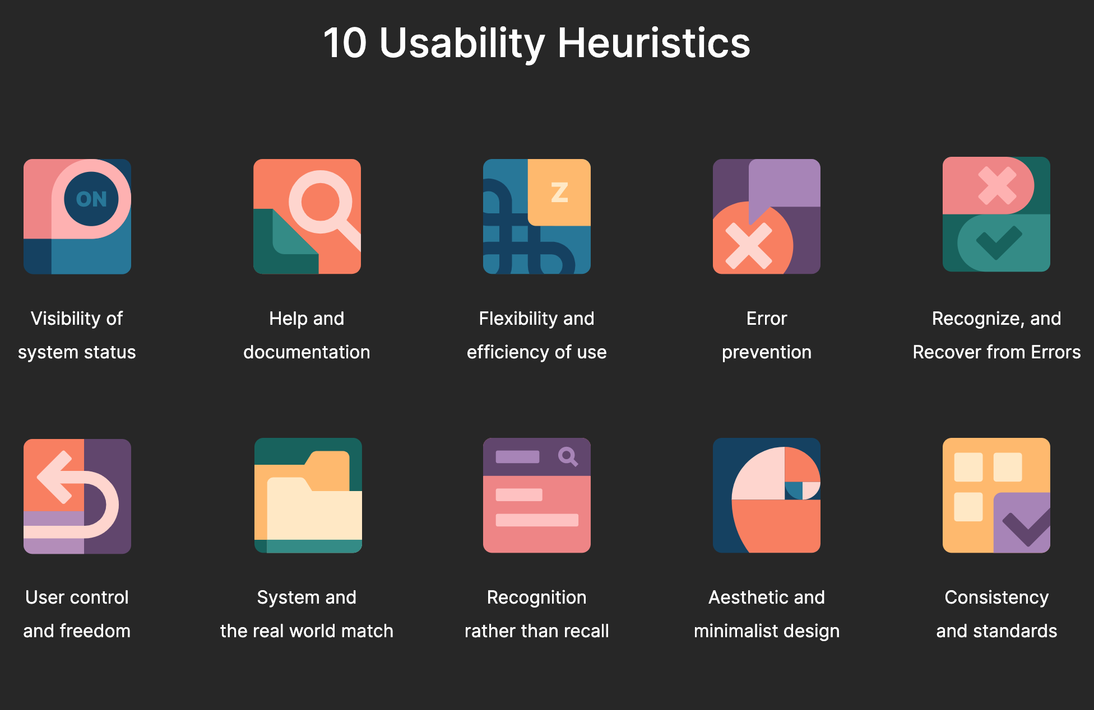

# 

**Severity**

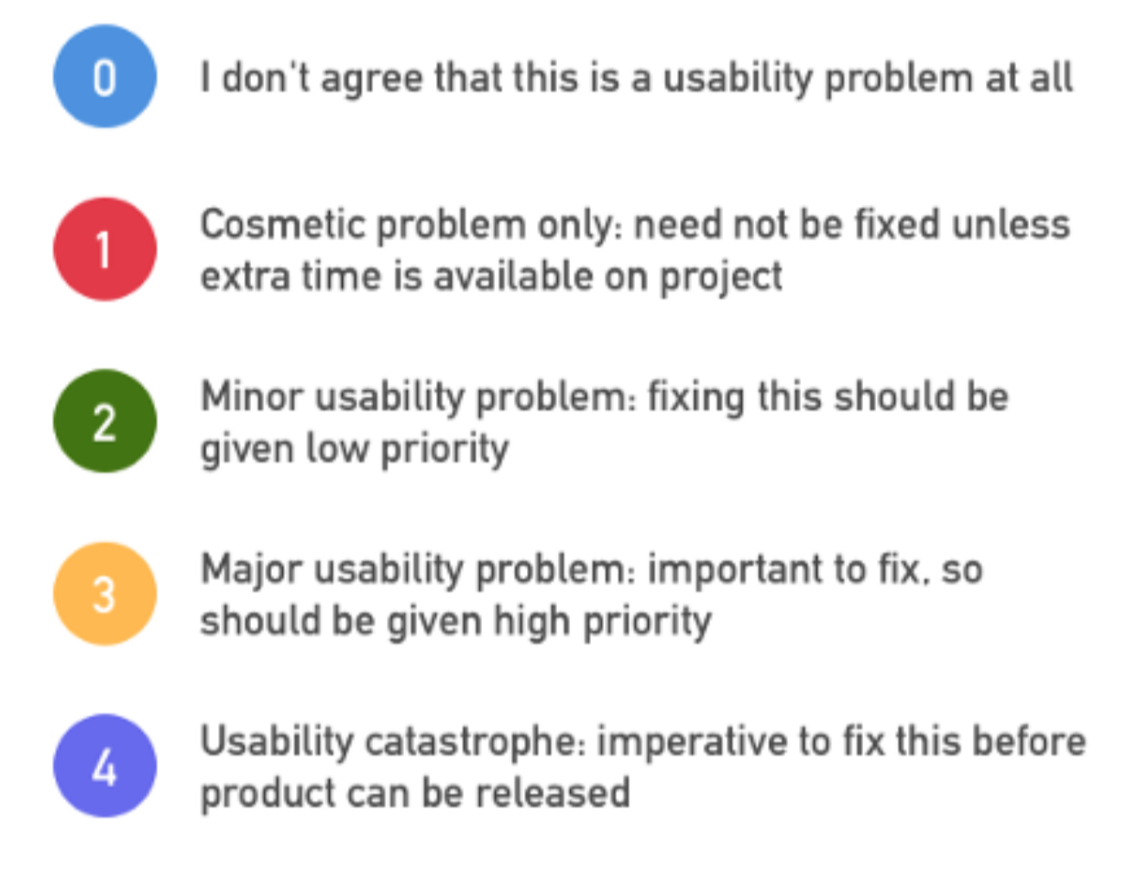

**EVALUATION**

**1. Visibility of System Status**

* Always keep users informed about what is going on.
* Provide appropriate feedback within a reasonable time.

***Evaluation***

**Issue (faced by the geriatric community in general)** - Having to question the presence/absence of various symbols and icons (Their usage etc..)

**Severity - 3 (Major Usability Problem)**

**Checklist**

1. Does every display begin with a title or header that describes screen contents? **YES**
2. Is every page annotated and marked appropriately? **YES**

**__________________________________________________________________**

**2. Match between System and the Real World**

* Speak the users' language, with words, phrases and concepts familiar to the user, rather than system-oriented terms.
* Follow real-world conventions, making information appear in a natural and logical order.

***Evaluation***

**Issue -** A lot of high-level languages are used in today’s app switch have made it hard for the majority of the community.

**Severity - 3 (Major Usability Problem)**

**Checklist**

1. Do the selected colours correspond to common expectations about colour codes?

**YES,** we have specifically taken care of this issue in our prototype.

1. Are the colours contrasting, are they easier to view and differentiate?

**YES**

**__________________________________________________________________**

**3. User Control and Freedom**

* Users often choose system functions by mistake.
* Provide a clearly marked "out" to leave an unwanted state without having to go through an extended dialogue.
* Support undo and redo.

***Evaluation***

**Issue -** Absence of an explicit ‘Back’ button in the interface. Creates a lot of confusion for the user.

**Severity - 3 (Major Usability Problem)**

**Checklist**

1. Can users cancel out of operations in progress?

**YES**

1. Can users go back to their previous page easily?

**YES**

**__________________________________________________________________**

**4. Consistency and Standards**

* Users should not have to wonder whether different words, situations, or actions mean the same thing.
* Follow platform conventions.

***Evaluation***

**Issue -** Rules and formatting styles aren’t the same everywhere. Lack of uniformity.

**Severity - 2 (Minor Usability Problem)**

**Checklist**

1. Have industry or company formatting standards been followed consistently everywhere?

**YES**

**_________________________________________________________________**

**5. Error Prevention**

* Even better than good error messages is a careful design that prevents a problem from occurring in the first place.

***Evaluation***

**Issue -** No issues.

___________________________________________________________________

**6. Recognition Rather than Recall**

* Make objects, actions, and options visible.
* Users should not have to remember information from one part of the dialogue to another.
* Instructions for use of the system should be visible or easily retrievable whenever appropriate.

***Evaluation***

**Issue -** Passwords are asked at multiple places, which can make it harder for the users to access the interface.

**Severity - 2 (Minor Usability Problem)**

**Checklist**

1. Are prompts, cues, and messages placed where the eye is likely to be looking on the screen? **YES**
2. Does the interface ask for passwords etc… at multiple places throughout the usage of the application? **NO**

____________________________________________________________________

**7. Flexibility and Efficiency of Use**

* Accelerators - unseen by the novice user -- may often speed up the interaction for the expert user so that the system can cater to both inexperienced and experienced users.
* Allow users to tailor frequent actions.

***Evaluation***

**Issue -** Easier movement across pages

**Severity - 2 (Minor Usability Problem)**

**Checklist**

1. Does the system allow experts to use shortcuts?

**YES**

1. Is the last system state saved for future use?

**YES**

_____________________________________________________________________

**8. Aesthetic and Minimalist Design**

* Dialogues should not contain information that is irrelevant or rarely needed.
* Every extra unit of information in a dialogue competes with the relevant units of information and diminishes their relative visibility.

***Evaluation***

**Issue -** Unnecessary extra information creates ambiguity and confusion.

**Severity - 1 (Cosmetic Problem)**

**Checklist**

1. Is only (and all) information essential to decision making displayed on the screen?

**YES**

**_________________________________________________________________**

**9. Help Users Recognise, Diagnose, and Recover from Errors**

* Expressed in plain language (no codes)
* Precisely indicate the problem
* Constructively suggest a solution.

***Evaluation***

**Issue -** Cryptic instructions, unclear information.

**Severity - 2 (Minor Usability Problem)**

**Checklist**

1. Do error messages suggest the cause of the problem (if any)?

**YES**

1. Are problems rightly diagnosed/addressed?

**YES**

**__________________________________________________________**

**10. Help and Documentation**

* Even though it is better if the system can be used without documentation, it may be necessary to provide help and documentation.
* Help information should be easy to search, focused on the user's task, list concrete steps to be carried out, and not be too large.

***Evaluation***

**Issue -** No issue (SELF EXPLANATORY)

__________________________________________________________________